

FACULTY OF ACCOUNTING AND INFORMATICS

DEPARTMENT OF INFORMATION SYSTEMS

QUALIFICATION TITLE:
Bachelor of Information and Communication Technology in IoT

INTEGRATED PROJECT PHASE 1

MODULES: WBDV202 & DTMG202

DURBAN UNIVERSITY OF TECHNOLOGY
Mobile Operating System Technology and Application (MOSA202)

GROUP MEMBERS

SM MNGADI: 25067504
N NDLOVU: 25091836
MH HLABISA: 25071875
AE NGUBANE: 25117712

L NODALI: 25047393
Campus Lost & Found
A cloud-connected Android application for reporting, approving and recovering lost items across DUT’s campuses

Introduction
PROJECT OVERVIEW.

Campus Lost & Found is an Android application created to help students report search for and manage lost and found items on campus. The application offers one place where students can create reports that include details like item type, category, title, description, location and photograph. Administrators can then. Manage these reports.

The system automatically classifies reports as HIGH, MEDIUM, LOW priority to help administrators prioritize urgent cases.

Firebase acts as the backend for Campus Lost & Found. Firebase Authentication manages user accounts. Cloud Firestore stores application data. Firebase Storage holds photographs uploaded with reports.

Campus Lost & Found also offers student registration and login, administrator registration and login lost and found reporting photograph uploading, AI‑style priority classification, administrator report management, search, category filtering, notifications, student‑administrator messaging, unread message indicators my reports and user profiles. The interface uses sky‑blue and white colors to give a consistent look.

Traditional lost‑and‑found processes often rely on physical notice boards, word of mouth or informal communication. This can make it hard for students to report items and for administrators to manage reports.

Campus Lost & Found was created to give a digital solution. The application lets students report lost and found items from their devices. Administrators can review these reports. Update their status. Students can also search for approved items. Communicate with administrators.

Problem statement
There is no central, searchable and moderated system through which students can report lost or found items, and no way of deciding which reports are most urgent

The main problems identified were:
1. Students may not know where to report lost or found items.
2.. Found information can become scattered across different communication channels.
3. Administrators may have difficulty managing reports manually.
4. Important reports may require attention.
5. Students need to know the status of their reports.
6. Students need a way to communicate with administrators.
7. Students need a way to search for items that have been found.

Solutions

1. Provide a Report Lost Item and Report Found Item feature.
2. Create one platform for all lost and found information.
3. Provide a dashboard to manage reports easily.
4. Add notifications for urgent reports.
5. Allow students to track the status of their reports.
6. Provide a communication feature between students and administrators.
7. Add search and filter options to help students find items easily.

The Campus Lost & Found application is developed to address these problems through one mobile platform.

Aim
The aim of the project is to develop an Android‑based Lost and Found Management System that allows students to report, search for and manage lost and found items while giving administrators tools to review reports and communicate with students.

Objectives
- Provide secure student registration, login and password reset using Firebase Authentication.
- Provide a separate administrator login with an approval process for new administrators.
- Allow students to report a Lost or Found item with category, title, description and location.
- Analyse every report with a rule-based “AI” classifier that produces a priority, a score out of 100, a written reason and an approval decision.
- Store users, reports and messages in Cloud Firestore and update screens in real time.
- Show only approved reports to students, with live search and category filters.
- Let administrators approve, reject, resolve, mark as claimed or delete reports, and notify the reporter of each decision.
- Allow administrators to review reports in Campus Lost & Found.
- Allow students to search for reports in Campus Lost & Found.
- Allow students to view their own reports in Campus Lost & Found.
- Provide a user profile in Campus Lost & Found.
- Provide a user‑friendly interface for Campus Lost & Found.
- Provide two-way messaging between students and administrators, and a user-management screen for the main administrator.
- Use a consistent blue Material-based interface that is easy to use on a phone.

Scope
The project delivers a complete Android client in Java connected to Firebase Authentication and Cloud Firestore. Items such as notifications through Firebase Cloud Messaging, and server-side security rules are outside this version and are listed under Future Work (Section 9).

2. System Overview

Users and roles
A role field stored on each user’s Firestore document controls what the person may do. Three roles exist.
Role | What they can do
Student (user) | They can register, login, and reset password. They can also report, claim, search, check the status of lost items. They can receive notifications, contact the admin, check their profile and log out.
Administrator (admin) | They have a different login format compared to the students, since students are required to enter their school email to register and login, administrators are required to enter their personal emails. Can view all reports, approve, reject and delete reports from students. They can also reply to the messages sent by the students and also log out.
Pending administrator | A person who used Create Admin Account. The account exists but cannot log in as an administrator until it is approved.
Main administrator | An administrator whose Firebase user ID is registered in the app as the main administrator. Only this account can open Manage Users, approve pending administrators and remove administrator rights.

Main features
Feature | Description
Welcome screen | Get Started (register), Login (student) and Login as Admin buttons.
Account management | Register with name, student number, email, phone and password, log in and reset password via email
Report an item | Select lost or found item, choose a category, enter the title. The description and the last location of the lost item, them you tap analyze and submit.
AI priority analysis | Gives priority, score, reason and an “automatically approved” or “sent to admin for review” decision.
Home dashboard | Greeting, notification bell, live search bar, category cards (Electronics, Books, Accessories, Others), the latest five approved reports and an unread-messages badge.
My Reports / Browse | Tabbed Lost / Found lists of approved reports; “View all” browses every user’s approved reports.
Item details | Details, status badge, Contact button (email) and, for the owner, a Mark as Resolved / Claimed button.
Notifications | Unread items stays highlighed on the admin panel.
Messages | Conversations between students and administrators.
Admin dashboard | Shortcut to view reports, student messages and manage users.
Report moderation | Filter reports by status and take action on each report.
Manage Users | Main administrator approves or revokes administrators.

3. Technology and Tools
Item | Details
Language | Java (Android SDK)
IDE / build system | Android Studio with Gradle; Android Gradle Plugin 8.6.1; Google Services plugin 4.4.2
SDK levels | minSdk 23 (Android 6.0), compileSdk 35, targetSdk 35
UI libraries | AndroidX AppCompat 1.7.0, Material Components 1.12.0, RecyclerView 1.3.2
Theme | Theme.Material3.DayNight.NoActionBar with a custom blue palette
Authentication | Firebase Authentication (email and password, password-reset email)
Database | Cloud Firestore with real-time snapshot listeners; collections users, reports and messages
Session cache | SharedPreferences file “CampusPrefs”
Other Firebase libraries | Firebase Storage and Firebase Cloud Messaging are included as dependencies for planned features
Permissions | INTERNET and POST_NOTIFICATIONS
Email contact | Implicit intent – Intent.ACTION_SENDTO with a mailto: URI

4. System Design

Architecture
The system uses a layered structure that separate the user interface from the logic and data Activities controls user input, interact with the Firebase and update the screen. XML layouts define the views, and three adapters feed the lists. User accounts, reports and messages live in the cloud, while a small SharedPreferences file caches the signed-in user.
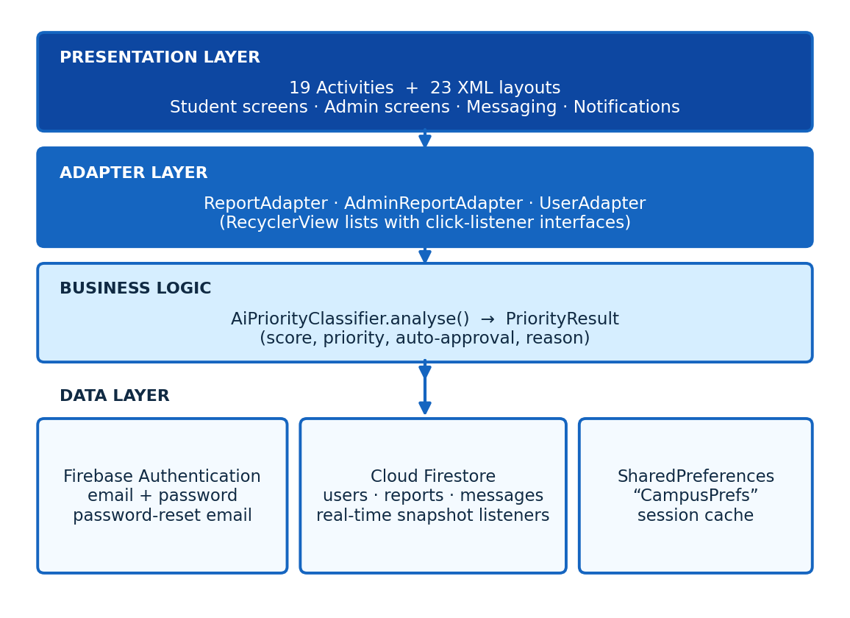

Classes and responsibilities
Class | Responsibility
LoginActivity | Welcome screen and launcher. Routes to registration, student login or admin login.
RegisterActivity | Validates the form (name, student number, email format, phone of at least 10 digits, password of at least 6 characters, matching confirmation), creates the Firebase account and saves the profile with role “user”.
LoginFormActivity | Firebase Authentication reads the user’s Firestore profile and role, caches it and opens Home.
ForgotPasswordActivity | Send a Firebase reset email if a user forgot their password.
HomeActivity | Student dashboard with live search, category filters, latest approved reports, notification bell, unread-message badge and bottom navigation.
ReportItemActivity | Report form; validates input, calls the classifier, saves the report to Firestore and shows the AI result.
MyReportsActivity | Lost / Found tabs in “mine” mode (own reports) or “all” mode (browse everyone’s).
ItemDetailsActivity | Shows a report, opens an email to the reporter, lets the owner resolve or claim it.
NotificationsActivity | Real-time list of administrator decisions on the student’s reports.
MessagesActivity | Student side of the chat with administrators.
ProfileActivity | Shows name, student number, email and phone; log out.
AdminLoginActivity / AdminRegisterActivity | Admin login that checks the role; admin account request that creates a pending_admin user.
AdminHomeActivity | Admin dashboard. Re-verifies the admin role from Firestore before showing anything.
AdminReportsActivity | All reports in real time with a status filter.
AdminReportDetailsActivity | Approve, reject, resolve, claim or delete a report, each with a confirmation dialog.
AdminMessagesActivity | Reads student messages and sends replies.
ManageUsersActivity | Main administrator only: lists users and approves or revokes administrators.
AdminPanelActivity | Statistics screen (totals, lost, found, resolved) that is declared but not linked from the current admin menu.
ReportAdapter, AdminReportAdapter, UserAdapter | RecyclerView adapters for student lists, admin lists and the user list.
AiPriorityClassifier, PriorityResult | Scoring engine and its immutable result (priority, score, autoApproved, reason).
ItemReport, UserModel | Model classes for a report and a user.
DbHelper | Legacy local SQLite helper from the first version. It is no longer used by any screen because data now lives in Firestore.

Navigation flow
LoginActivity is the launcher. Students move from login to HomeActivity, which is the hub for reporting, browsing, notifications, messages and the profile.
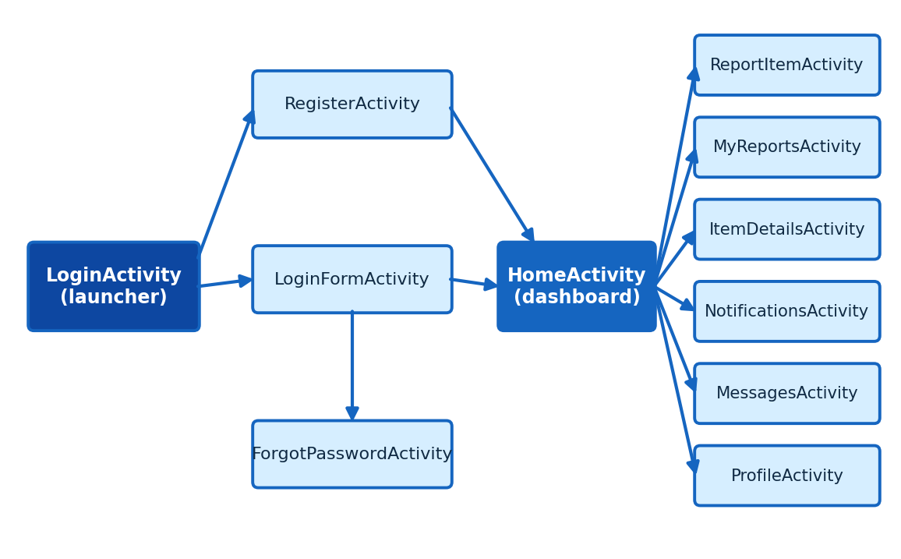
Administrators enter through Admin Login. AdminHomeActivity leads to report moderation, student messages and user management.
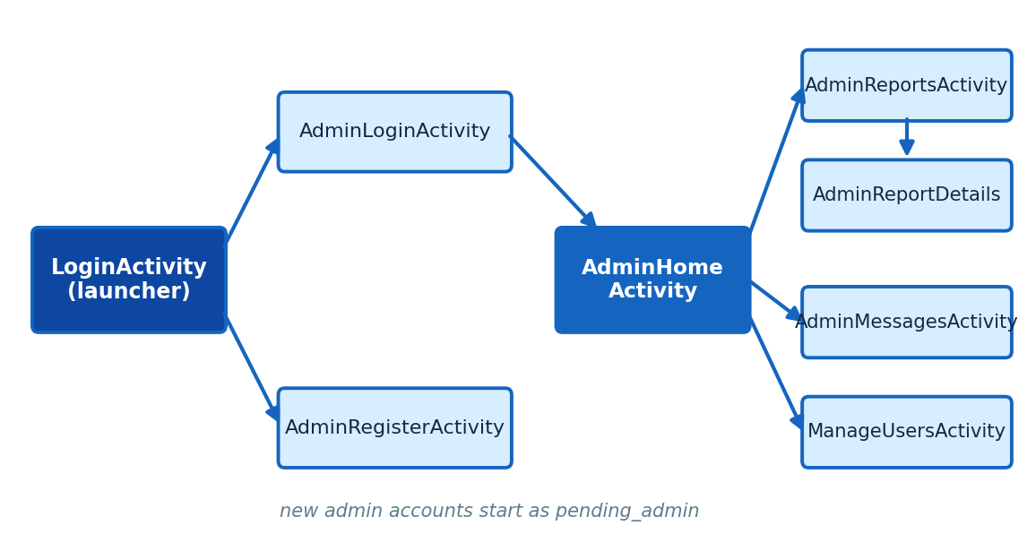

Data design
Cloud Firestore stores data as documents inside three collections. The Firebase user ID (uid) links an authenticated person to their documents.
Collection | Fields
users | uid, name, studentNumber, email, phone, role (user, pending_admin or admin). The document ID is the user’s uid.
reports | id, type (Lost / Found), category, title, description, location, photoUri, photoUrl, priority, score, status, reporterName, reporterEmail, reporterUid, studentNumber, dateDisplay, timestamp, notification, notificationRead.
messages | senderUid, senderEmail, senderName, senderRole, receiverUid, receiverRole, message, timestamp, read.
Each report moves through a simple lifecycle held in the status field, shown below. Reports start as Approved when the classifier approves them automatically, otherwise as Pending. Administrators approve or reject pending reports, and approved reports end as Resolved (lost items) or Claimed (found items).
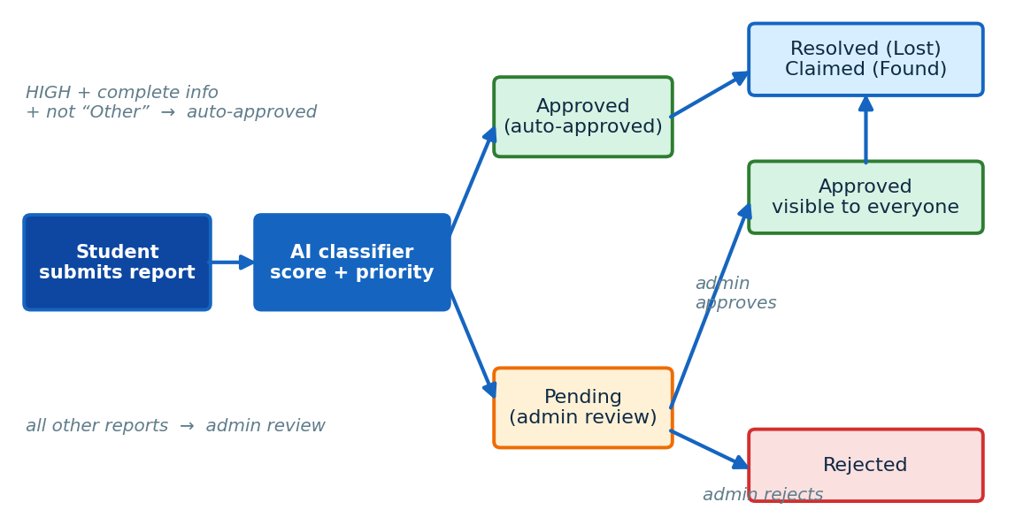

5. Implementation

Registration and login
RegisterActivity validates every field with a clear message, then calls createUserWithEmailAndPassword(). When Firebase creates the account, the activity writes a document to users/{uid} containing the profile and the role “user”, caches the basics in SharedPreferences, and opens Home with the back stack cleared. LoginFormActivity calls signInWithEmailAndPassword(), reads users/{uid} to learn the name and role, stores them in CampusPrefs and opens Home. Passwords are handled only by Firebase and are never stored in the app.
firebaseAuth.createUserWithEmailAndPassword(email, password)
.addOnCompleteListener(this, task -> {
if (task.isSuccessful()) {
userData.put("role", "user");
firestore.collection("users").document(uid).set(userData);
}
});

ForgotPasswordActivity validates the email address and calls sendPasswordResetEmail(), so students can recover their own accounts.

Administrator accounts and roles
The welcome screen has a separate Login as Admin button. Create Admin Account registers a normal Firebase user but stores the role pending_admin and immediately signs the person out. AdminLoginActivity signs in, reads the role and then decides: pending_admin shows “waiting for approval”, any role other than admin is refused, and only admin opens AdminHomeActivity. In every refused case the user is signed out. AdminHomeActivity checks the role again when it opens, so a screen cannot be reached by simply launching it.
ManageUsersActivity is restricted to the main administrator. It compares the signed-in uid with the main administrator’s uid and checks that the stored role is admin; otherwise it signs the user out. It then lists every user, and a button on each row switches a pending_admin to admin or an admin back to user.

Reporting an item
ReportItemActivity fills two spinners (Lost / Found and eight categories: Laptop, Cellphone, Student Card, Book, Tablet, Calculator, Headphones, Other). When the student presses Analyse & Submit the activity:
- checks that title, description and location are filled in;
- calls AiPriorityClassifier.analyse(category, title, description);
- reads the student’s name and student number from users/{uid};
- creates a new document in reports with a generated ID, the classifier’s priority and score, the reporter’s details, a timestamp and a readable date such as “29 Sep 2026 · 03:15 PM”;
- sets the status to Approved when the classifier approved the report automatically, otherwise to Pending;
- shows a dialog with the priority, score, approval decision and reason.

The AI priority classifier
The classifier is a transparent, rule-based scoring engine, which means every decision can be explained to the student. The selected category gives the base score. Using the category first prevents mistakes such as the word “phone” inside “headphones” changing the result. Only when the category is Other does the classifier search the title and description for keywords, using a regular expre
ssion that matches whole words only. Academic words (assignment, exam, test, lecture, class, project, study) and urgency words (urgent, tomorrow, deadline) add sentences to the explanation shown to the student.
Category (or keyword when “Other”) | Score | Reason recorded
Laptop (laptop, computer, notebook) | 90 | High-priority study device
Cellphone (phone, smartphone) | 80 | Important for communication and student services
Student Card (student id, id card) | 70 | Needed for campus access and services
Tablet (tablet, ipad) | 60 | Possible study device
Book (textbook, notes) | 50 | Study material
Calculator | 50 | Needed for coursework and tests
Headphones (earphones, earbuds) | 40 | Useful for study and communication
Anything else | 30 | Does not match a higher-priority category

Score | Priority | Effect
70 – 100 | HIGH | Automatically approved if title, description and category are present and the category is not “Other”.
40 – 69 | MEDIUM | Status Pending – sent to an administrator.
0 – 39 | LOW | Status Pending – sent to an administrator.

In practice, reports for a laptop, a cellphone or a student card are approved immediately, and all other reports wait for an administrator. A lost water bottle scores 30, which is LOW, and goes to an administrator. The whole engine sits behind one static method and one result class, so it can later be replaced by a machine-learning or generative-AI service without changing the reporting screen.
if (safeCategory.equalsIgnoreCase("Laptop")) { score = 90; ... }
else if (safeCategory.equalsIgnoreCase("Cellphone")) { score = 80; ... }
...
String priority = score >= 70 ? "HIGH" : score >= 40 ? "MEDIUM" : "LOW";
boolean autoApproved = priority.equals("HIGH") && enoughInformation
&& !safeCategory.equalsIgnoreCase("Other");

Home screen: live data, search and filters
HomeActivity attaches a Firestore snapshot listener to reports whose status is Approved, so a report appears or disappears on every student’s screen the moment an administrator changes it. Each document is converted into an ItemReport and the list is sorted newest first. A TextWatcher filters this list as the student types, matching the title, description, category and location. The four category cards (Electronics, Books, Accessories, Others) each map to a list of stored categories. With no search text and no filter, only the five latest reports are shown. A second listener on the messages collection counts unread administrator replies and shows the number as a badge on the Messages tab. The listeners are removed when the screen is destroyed.

Lists, details and contact
ReportAdapter, AdminReportAdapter and UserAdapter bind data to rows in RecyclerView lists, and each exposes a small click-listener interface so the activity decides what a tap does. MyReportsActivity queries reports by type (and by the signed-in email in “mine” mode) and then keeps only Approved reports. ItemDetailsActivity loads a report, and the Contact button starts an implicit email intent to the reporter with a subject naming the item. The Mark as Resolved (Lost) or Mark as Claimed (Found) button appears only when the signed-in email equals the reporter’s email and the item is not already closed.

Administrator moderation
AdminReportsActivity listens to the whole reports collection and filters it by status (All Reports, Pending, Approved, Rejected, Resolved, Claimed). AdminReportDetailsActivity shows the full report and the classifier’s score, and displays buttons that suit the current status: Approve and Reject for Pending reports, Mark as Resolved for approved Lost reports, Mark as Claimed for approved Found reports, and Delete. Every action asks for confirmation in an AlertDialog and then updates the status together with a notification text for the student.
reportReference.update(
"status", "Approved",
"notification", "Your reported item has been approved and is now visible to users.",
"notificationRead", false);

Notifications
Notifications are stored on the report itself in the notification and notificationRead fields. NotificationsActivity listens to reports where reporterEmail equals the student’s email, keeps those with a notification text, and shows them newest first with an unread badge. Tapping a card marks it as read and opens the report.

Messaging
Every message is a document in the messages collection that records who sent it, the sender’s role, the receiver’s role and uid, the text, a timestamp and a read flag. A student’s message is addressed to the role admin. MessagesActivity shows messages the student sent together with replies addressed to them, sorts them by time, aligns administrator messages differently and marks unread replies as read. AdminMessagesActivity listens to all messages addressed to administrators, lets the administrator choose a student and send a reply addressed to that student’s uid.

Android concepts applied
Concept | Where it is used
Activities and the manifest | Nineteen activities declared in AndroidManifest.xml with exported=false, except the launcher LoginActivity.
Activity life cycle | onCreate() builds screens and attaches listeners; onDestroy() removes Firestore listeners to avoid leaks.
Explicit intents with extras | Navigation, report_id and mode extras.
Implicit intents | ACTION_SENDTO to email a reporter.
Back stack control | FLAG_ACTIVITY_NEW_TASK | FLAG_ACTIVITY_CLEAR_TASK after login and logout.
Permissions | INTERNET for Firebase; POST_NOTIFICATIONS declared.
Resources | 23 layouts, 28 drawables, colours, styles and strings.
RecyclerView and adapters | Report lists and the user list.
Asynchronous callbacks and real-time listeners | Firebase tasks and addSnapshotListener().
SharedPreferences | Session cache.
Cloud services | Firebase Authentication and Cloud Firestore.
Input validation and feedback | Toasts, EditText errors and AlertDialogs.

6. Testing
The following scenarios were defined from the behaviour of the code to verify each requirement. They can be repeated on an emulator or a physical device running Android 6.0 or later with an internet connection.
# | Scenario | Expected result
1 | Register with an invalid email or a phone under 10 digits | A message explains the problem; no account is created.
2 | Register with mismatching passwords | “Passwords do not match.”
3 | Register with valid details | Firebase account and users/{uid} document created with role user; Home opens.
4 | Log in with a wrong password | Error message from Firebase; stays on the login form.
5 | Use Forgot password with a valid email | A reset email is sent.
6 | Create an admin account, then log in as admin | Message that the account awaits approval; no admin access.
7 | Main admin approves the pending admin in Manage Users | Role changes to admin; the person can now log in as admin.
8 | Student logs in through Admin Login | “Not an approved administrator account”; signed out.
9 | Report a Laptop with all fields filled in | Score 90, HIGH, automatically approved; status Approved and visible on Home.
10 | Report a Book or an Other item | Not auto-approved; status Pending and not visible on Home.
11 | Admin approves a pending report | Report appears on every student’s Home in real time; reporter receives a notification.
12 | Admin rejects a pending report | Reporter’s notification says it was rejected; report never appears on Home.
13 | Type part of a title or location in the search bar | The list narrows instantly.
14 | Tap the Books category card | Only Book reports are listed.
15 | Owner opens an approved report and presses Mark as Resolved / Claimed | Status changes; report leaves the Home and My Reports lists.
16 | Student sends a message; admin replies | Reply appears in the student’s Messages screen; unread badge shows on Home until it is read.
17 | Open Manage Users with a normal admin account | Access denied and signed out.
18 | Log out, then press Back | Login screen remains; signed-in screens are not shown.

7. Challenges and Limitations
- Photos Photos are not yet uploaded. The report form shows a photo option, but this version saves the report without a photo (the photo fields are empty); Firebase Storage is included as a dependency for a later release.
- No push notifications. Notifications are in-app and update in real time while the app is running. Firebase Cloud Messaging and the notification permission are declared but a messaging service is not yet implemented.
- Security relies on the client. Role checks are performed in the app. Firestore security rules (not part of the project files) must also enforce roles on the server, and the main administrator’s user ID is written inside the app code.
- Reports are looked up by timestamp. The creation time in milliseconds is used as the identifier passed between screens. This works for a small system but a Firestore document ID would be more reliable.
- Rule-based classifier. It depends on categories and keywords and cannot understand free-text descriptions.
- Legacy and unused code. DbHelper (SQLite) and AdminPanelActivity remain from earlier versions and are no longer part of the main flow.
- No automated tests. Testing is by manual scenarios.
- Only 3 DUT Campuses(Steve Biko, ML Sultan and Ritson) are included in the app.

8. Challenges Overcome
Moving from a local database to the cloud changed how every screen loads data: results arrive asynchronously, so each screen shows a loading or empty message and updates when the data arrives. Real-time listeners keep lists current but must be removed when a screen closes, which is done in onDestroy(). The classifier was improved to use the selected category first and whole-word matching second, after noticing that a keyword such as “phone” also appears inside “headphones”. Finally, a two-level administrator approval process was added so that nobody can become an administrator simply by registering.

9. Future Work
- Upload photos to Firebase Storage and show them in lists and details.
- Send push notifications with Firebase Cloud Messaging when a report is approved or a reply arrives.
- Add Firestore security rules that enforce student, admin and main-admin permissions on the server.
- Use Firestore document IDs instead of timestamps, and remove the legacy SQLite code.
- Replace the keyword classifier with a machine-learning or generative-AI model behind the same analyse() method.
- Match lost and found reports automatically by category and location, and add campus selection for DUT’s three campuses.
- Add unit and instrumentation tests.

10. Conclusion
Campus Lost & Found meets the objectives of the MOSA202 Integrated Project. It is a complete Android application written in Java and connected to Firebase in which students register securely, report lost and found items, receive an automatic priority analysis, search approved items in real time, receive notifications and message administrators, while administrators moderate reports, reply to students and manage who may act as an administrator. The project applied the module’s core concepts: activities and the life cycle, intents, resources, RecyclerView, local session storage and cloud services, within a clean layered design. The foundation is ready to grow with photo upload, push notifications and server-side security.

Appendix A: Project structure
CampusLostFound/
build.gradle, settings.gradle, gradle.properties
app/build.gradle, app/google-services.json
app/src/main/
AndroidManifest.xml
java/com/example/campuslostfound/ (27 classes)
Student: LoginActivity, RegisterActivity, LoginFormActivity,
ForgotPasswordActivity, HomeActivity, ReportItemActivity,
MyReportsActivity, ItemDetailsActivity, NotificationsActivity,
MessagesActivity, ProfileActivity
Admin: AdminLoginActivity, AdminRegisterActivity, AdminHomeActivity,
AdminReportsActivity, AdminReportDetailsActivity,
AdminMessagesActivity, ManageUsersActivity, AdminPanelActivity
Support: ReportAdapter, AdminReportAdapter, UserAdapter,
ItemReport, UserModel, PriorityResult,
AiPriorityClassifier, DbHelper (legacy)
res/layout/ 23 layout files
res/drawable/ 28 shape and icon drawables
res/values/ colors.xml, styles.xml, strings.xml

Appendix B: How to build and run
- Extract the project zip and open the folder in Android Studio.
- Make sure google-services.json is in the app folder and the device or emulator has internet access.
- Allow Gradle to sync (Android Gradle Plugin 8.6.1, compileSdk 35).
- Run on an emulator or a phone with Android 6.0 or later or a mobile device.
- Register a student account to use the student features. To test administration, use an approved administrator account.

REFERENCES.

1. Android Developers. (2024). Android Documentation. Https://developer.android.com

2. Firebase. (2024). Firebase Documentation. Https://firebase.google.com/docs

3. Google. (2024). Material Design Guidelines. Https://material.io/design

4. Oracle. (2024). Java Documentation. Https://docs.oracle.com/javase

5. Android Studio. (2024). Android Studio User Guide. Https://developer.android.co

